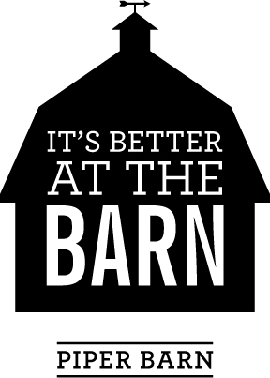

Welcome to the 2017 Piper Barn Show!

Registration is now open for the 2017 Piper Barn Show! We are currently registering new vendors and would love to hear from you!

2017 Show Dates:

Wednesday November 1 12pm-7pm
Thursday & Friday November 2-3 10am-7pm
Saturday November 4 9am-3pm

Our show is held in the Piper Family Barn; a 100 year old barn in a picturesque country setting just 10 miles east of Moses Lake, WA. (Please see our Facebook and Instagram pages for pictures from last year’s show) We feature Christmas items and gifts, hand crafted goods, vintage finds, antiques and collectibles as well as unique food selections. Last year our show had our highest attendance to date and received rave reviews from our customers! We anticipate an even bigger show in 2017!

Piper Barn Show is a boutique-style show and features a central check out for customer convenience. We cover all credit card fees for our vendors as well as bags and wrapping materials at checkout. All items for sale are integrated throughout the barn so it has a ‘store-like’ appearance. No booths for individual vendors! We love the way it looks and so will you! We encourage you to bring some of your own props for display purposes. Baskets or bins for display of smaller items is helpful. Maybe even a small sign or two with descriptions and uses for items. Please let us know what you will bring, as space is limited and must be carefully planned. If you have antique or other furniture pieces, either for display or sale, we could use these for set up. We provide a large Christmas tree and display as the centerpiece of the barn to display ornaments and other goods for sale.

This will be our third year selling from the “Bins at Piper Barn”, aka the 2 grain silos next to the barn. They are an amazing venue and so fun to have for our use! This year we will continue with our “Children’s Silo” and the second bin will be themed “Christmas in the Country”.

We are looking for crafters, up-cyclers, and creative artisans to join in this unique event! Quality handcrafted items, Christmas ornaments and decor, vintage Christmas décor and gifts, children’s items, toys, upcycled and refurbished items, vintage finds, antiques, and collectibles are included in the look we want! The Piper Barn Show is juried to ensure the desired Piper Barn “look”. Pictures of the types of items you wish to sell will be required before registration to minimize inventory duplication.

Piper Barn charges a $50 non-refundable entry fee per artist. A 20% commission is charged on total sales. In addition, each artist is asked to work a minimum 4 hour shift during the show to help with refilling displays, check out, parking, or wherever needed. If you live outside our immediate area, we are flexible with our work schedule and other arrangements can be discussed

We will handle all advertising including fliers/mailers, radio and newspaper ads, a dedicated Facebook and Instagram page, as well as an exclusive Piper Barn Pinterest page for you to display your work and create excitement before the event!
We will only be accepting 80 vendors this year! Please return the registration and fee as soon as possible to Julie Piper Phipps to ensure your place in the barn! Your place will not be held until I have BOTH the registration form and fee.**

Julie Piper Phipps 4416 Road Q NE, Moses Lake, WA 98837
Cell (719) 649-8355
Email: PiperBarn@gmail.com

*Registration may be paid with cash or check made out to “Julie Phipps” or “Barn 4 Boutique” and sent to the above address.

**After completion of registration, each vendor will be assigned a vendor number and detailed instructions on how to list your vendor number, inventory number, and price on EACH sales tag to insure proper credit for sales.

We are excited to have you as a vendor! The barn can only hold 80 vendors and spaces fill fast! November will be here before we know it! Please call me with any questions at the number or email listed above. I would be happy to help!

Julie Piper Phipps
Event Organizer

